**1.write a python code to read an image?**

**AIM**: To write a python code to read an image using open cv.

**PROGRAM**

import cv2

image = cv2.imread("C:/Users/ankal/OneDrive/Desktop/naruto/butterfly.jpg")

cv2.imshow('Image', image)

cv2.waitKey(0)

cv2.destroyAllWindows()

**OUTPUT**

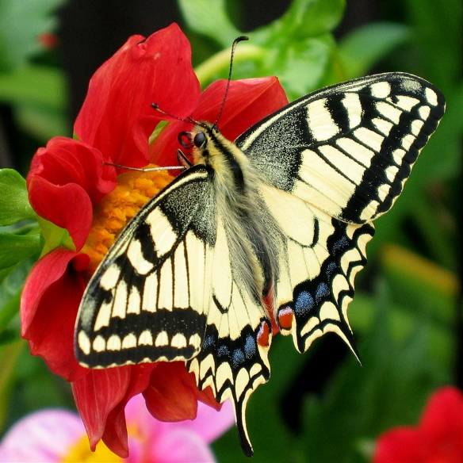

**2.write a python code to display an image?**

**AIM:** To write a python code to display an image using open cv.

**PROGRAM**

import cv2

image = cv2.imread("C:/Users/ankal/OneDrive/Desktop/naruto/butterfly.jpg")

cv2.imshow('Image', image)

cv2.waitKey(0)

cv2.destroyAllWindows()

**OUTPUT**



**3.Perform colour conversion in open cv?**

**AIM:** To write a python code to perform colour conversions using open cv.

**PROGRAM**

import cv2

image = cv2.imread("C:/Users/ankal/OneDrive/Desktop/naruto/butterfly.jpg")

gray_image = cv2.cvtColor(image, cv2.COLOR_BGR2GRAY)

cv2.imshow('Grayscale Image', gray_image)

cv2.waitKey(0)

cv2.destroyAllWindows()

**OUTPUT**

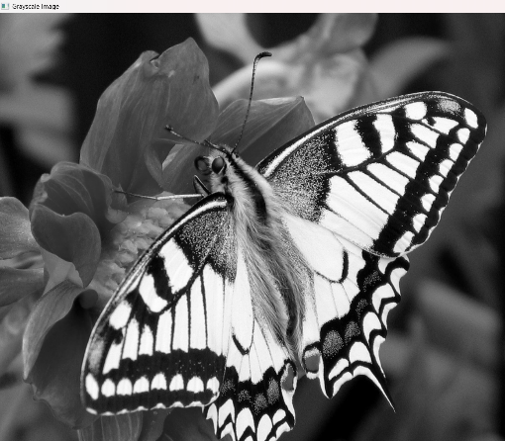

**4.Perform Gaussian Filter’s in open cv?**

**AIM:** To write a python code to perform Gaussian Filter’s using open cv.

**PROGRAM**

import cv2

image = cv2.imread("C:/Users/ankal/OneDrive/Desktop/naruto/butterfly.jpg")

blurred_image = cv2.GaussianBlur(image, (5, 5), 0)

cv2.imshow('Gaussian Blurred Image', blurred_image)

cv2.waitKey(0)

cv2.destroyAllWindows()

**OUTPUT**

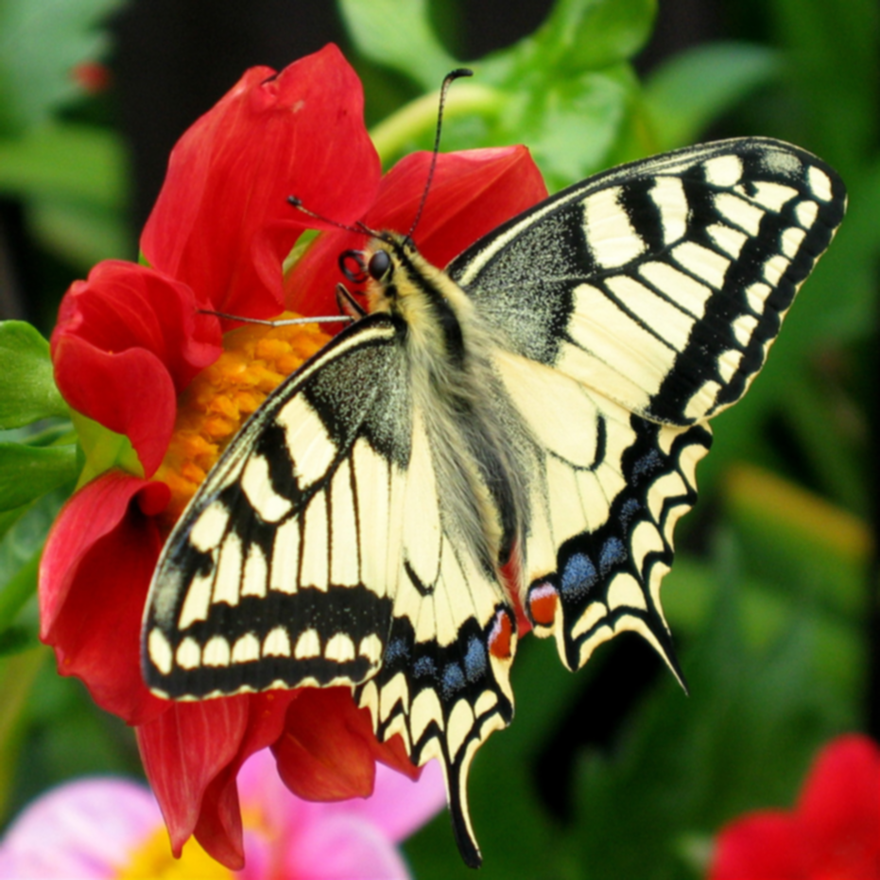

**5.Perform canny operator in open cv?**

**AIM:** To write a python code to perform Canny Operator using open cv.

**PROGRAM**

import cv2

image = cv2.imread("C:/Users/ankal/OneDrive/Desktop/naruto/butterfly.jpg", cv2.IMREAD_GRAYSCALE)

blurred_image = cv2.GaussianBlur(image, (5, 5), 1.5)

edges = cv2.Canny(blurred_image, 50, 150)

cv2.imshow('Canny Edges', edges)

cv2.waitKey(0)

cv2.destroyAllWindows()

**OUTPUT**

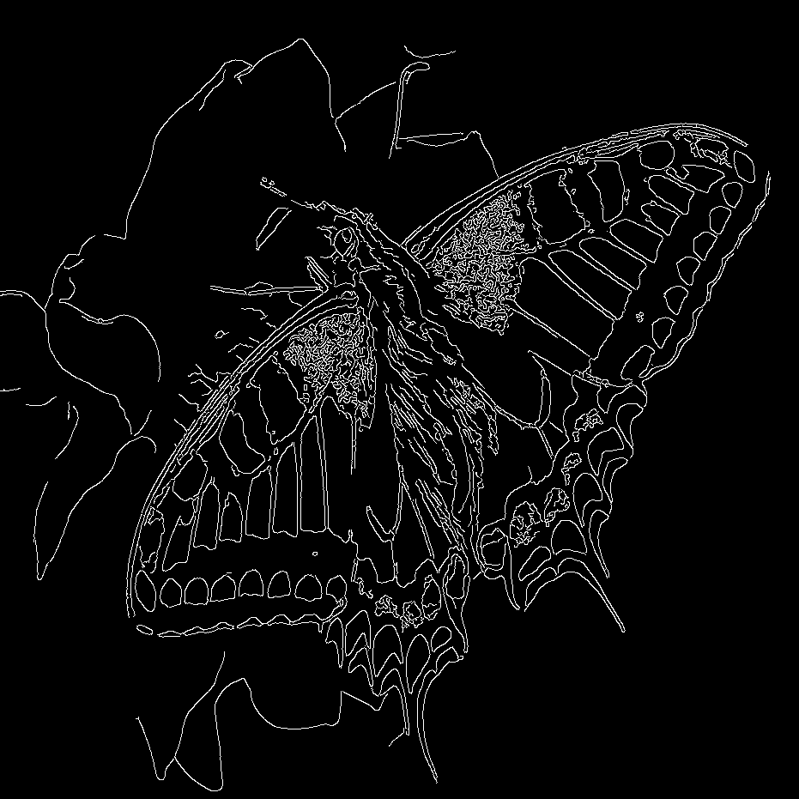

**6.Perform Dilation of the image in open cv?**

**AIM:** To write a python code to perform Dilation of the Image using open cv.

**PROGRAM**

import cv2

import numpy as np

image = cv2.imread( "C:/Users/ankal/OneDrive/Desktop/naruto/butterfly.jpg", 0)

kernel = np.ones((5, 5), np.uint8)

dilated_image = cv2.dilate(image, kernel, iterations=1)

cv2.imshow('Original Image', image)

cv2.imshow('Dilated Image', dilated_image)

cv2.waitKey(0)

cv2.destroyAllWindows()

**OUTPUT**

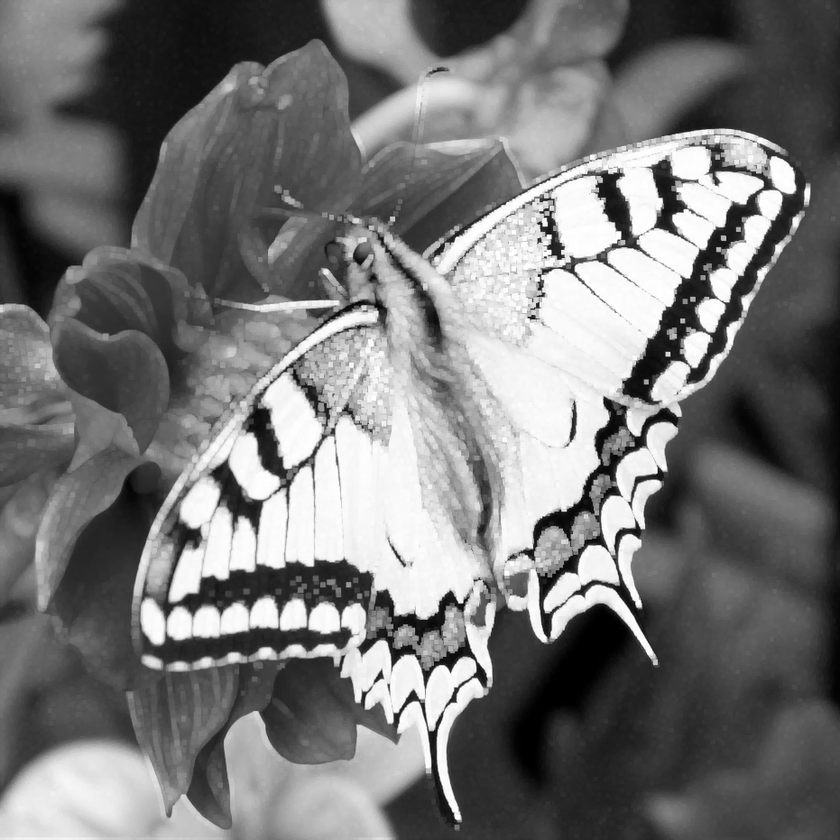

**7.Perform Erode of the image in open cv?**

**AIM:** To write a python code to perform Erode of the Image using open cv.

**PROGRAM**

import cv2

import numpy as np

image = cv2.imread("C:/Users/ankal/OneDrive/Desktop/naruto/butterfly.jpg",

cv2.IMREAD_GRAYSCALE)

_, binary_image = cv2.threshold(image, 127, 255, cv2.THRESH_BINARY)

kernel = np.ones((5, 5), np.uint8)

eroded_image = cv2.erode(binary_image, kernel, iterations=1)

cv2.imshow('Eroded Image', eroded_image)

cv2.waitKey(0)

cv2.destroyAllWindows()

**OUTPUT**

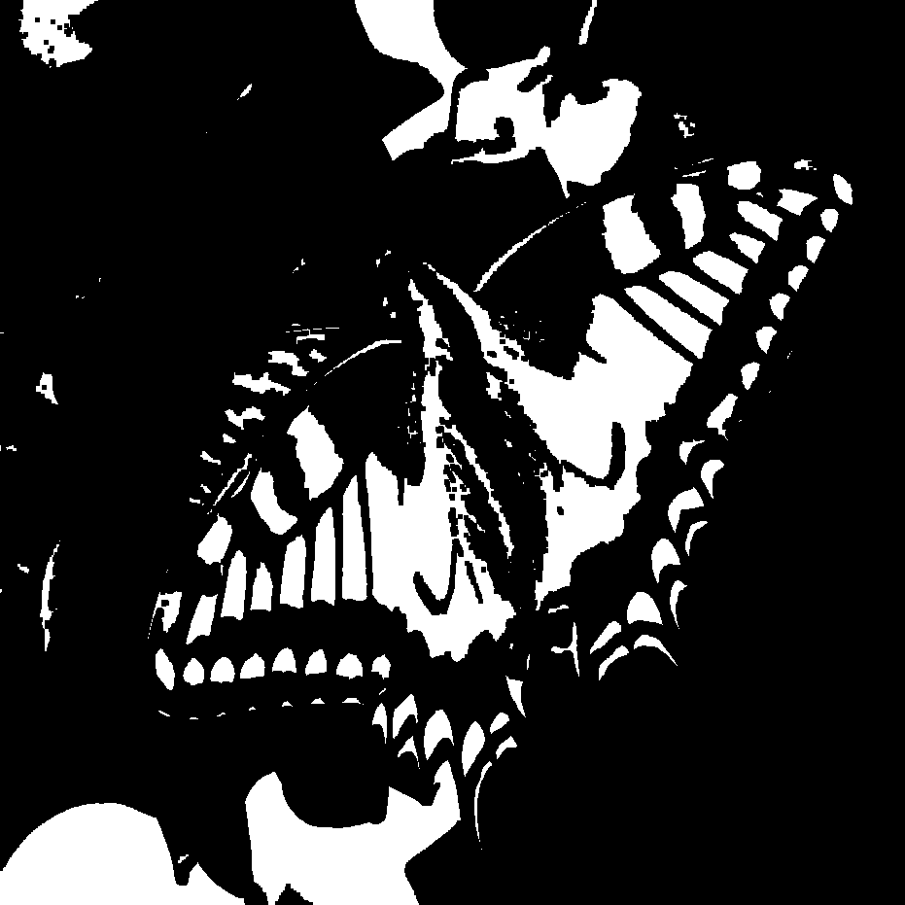

**8.How to read a video in the python program using open cv?**

**AIM:** To write a python code to read the video using open cv.

**PROGRAM**

import cv2

cap = cv2.VideoCapture("C:/Users/ankal/Videos/Screen Recordings/Screen Recording 2024-09-04 143540.mp4")

if not cap.isOpened():

print("Error: Could not open video.")

exit()

while True:

ret, frame = cap.read()

if not ret:

break

cv2.imshow('Video Frame', frame)

if cv2.waitKey(30) & 0xFF == ord('q'):

break

cap.release()

cv2.destroyAllWindows()

**OUTPUT**

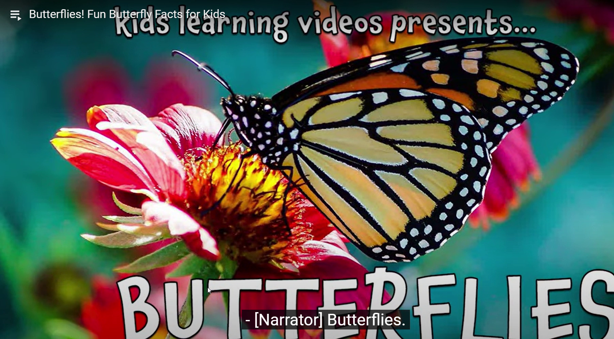

**9.Perform to resize the image using open cv?**

**AIM:** To write a python code to perform resize of an image using open cv.

**PROGRAM**

import cv2

image = cv2.imread("C:/Users/ankal/OneDrive/Desktop/naruto/butterfly.jpg")

resized_image = cv2.resize(image, (1000, 800), interpolation=cv2.INTER_LINEAR)

cv2.imshow('Original Image', image)

cv2.imshow('Resized Image', resized_image)

cv2.waitKey(0)

cv2.destroyAllWindows()

**OUTPUT**

Original Image

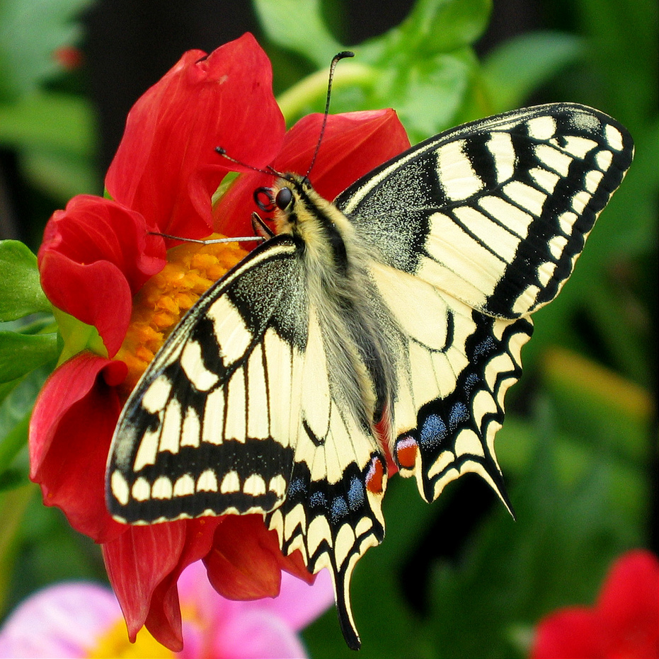

Resized Image

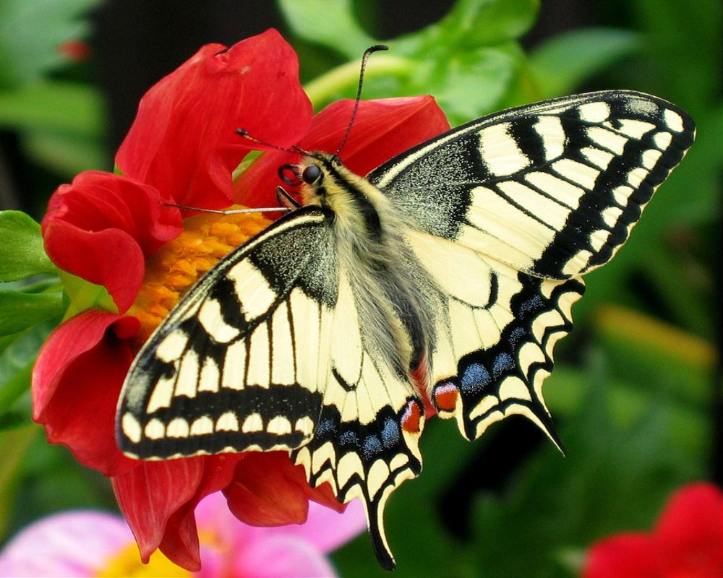

**10.Perform the Rotation of the Image using open cv?**

**AIM:** To write a python code to perform a Rotation of an image using open cv.

**PROGRAM**

import cv2

import numpy as np

image = cv2.imread("C:/Users/ankal/OneDrive/Desktop/naruto/butterfly.jpg")

(h, w) = image.shape[:2]

center = (w // 2, h // 2)

angle = 90

scale = 1.0

M = cv2.getRotationMatrix2D(center, angle, scale)

rotated_image = cv2.warpAffine(image, M, (w, h))

cv2.imshow("Original Image", image)

cv2.imshow("Rotated Image", rotated_image)

cv2.waitKey(0)

cv2.imwrite('rotated_image.jpg', rotated_image)

cv2.destroyAllWindows()

**OUTPUT**

**Original Image**



Rotated Image

